Concepts And Historical Underpinnings
Concept
Normal

1.Which of the following best explains the core objective of "Digital Constitutionalism"?
(a) Replacement of Constitution with digital laws
(b) Application of constitutional principles to digital governance and technologies
(c) Complete deregulation of digital platforms
(d) Establishment of global digital government
Answer: (b)
Solution:
- (a) Replacement of Constitution with digital laws =Incorrect
Digital Constitutionalism does not aim to replace the Constitution. It builds upon existing constitutional frameworks and applies them to the digital sphere. The word “replacement” makes it an extreme and incorrect statement.
- (b) Application of constitutional principles to digital governance and technologies =Correct
This is the core idea. It ensures that digital systems (AI, data, platforms) follow constitutional values like:
  - Fundamental Rights (privacy, free speech)
  - Rule of Law
  - Accountability
- (c) Complete deregulation of digital platforms =Incorrect
Digital Constitutionalism actually promotes regulation and accountability of digital platforms, not deregulation. The phrase “complete deregulation” is extreme → false.
- (d) Establishment of global digital government =Incorrect
It does not propose any global digital authority. It works within existing national constitutional systems, though it may influence global norms.

Concepts And Historical Underpinnings
Concept
Statement
2. Consider the following statements regarding Digital Constitutionalism:
- It seeks to subject digital power to constitutional limits.
- It applies only to state actors and excludes private digital platforms.
Which of the statements given above is/are correct?
(a) 1 only
(b) 2 only
(c) Both 1 and 2
(d) Neither 1 nor 2
Answer: (a)
Solution:
- Statement 1 =Correct
Digital Constitutionalism aims to limit digital power (both state and private) using constitutional principles like fundamental rights, rule of law, and accountability. It ensures that digital technologies and platforms do not operate beyond constitutional scrutiny.
- Statement 2 =Incorrect
It is not limited to state actors. Digital Constitutionalism also covers private digital platforms (Big Tech) because they exercise significant power over speech, data, and access. Hence, excluding private actors makes the statement incorrect.

ICT
Concept
Pair
3.Consider the following pairs:
Concept =Explanation
- Net Neutrality =Equal treatment of internet data
- Algorithmic Bias =Neutral decision-making by AI
- Digital Surveillance =Monitoring through digital tools
How many pairs given above are correctly matched?
(a) Only one
(b) Only two
(c) All three
(d) None
Answer: (b)
Solution:
- Pair 1 =Correct
Net Neutrality =Equal treatment of internet data
This correctly defines net neutrality, which ensures that all internet traffic is treated equally without discrimination or prioritization.
- Pair 2 =Incorrect
Algorithmic Bias =Neutral decision-making by AI
This is incorrect. Algorithmic bias refers to systematic errors or unfair outcomes in AI systems, often due to biased data or design—not neutrality.
- Pair 3 =Correct
Digital Surveillance =Monitoring through digital tools
This is accurate, as digital surveillance involves tracking or monitoring individuals using digital technologies like cameras, data tracking, or online activity analysis.

ICT
Concept
NormalCSAT
4.
(a)
(b)
(c)
(d)
Answer:(b)
Solution:
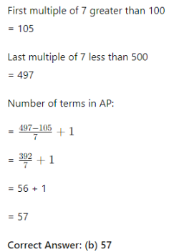
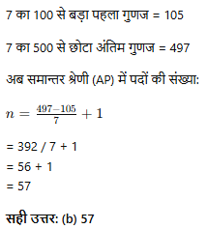

ICT
Concept
StatementCSAT
5.
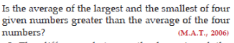
1.
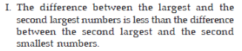
2.
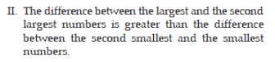
3.
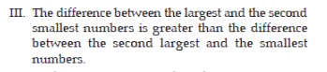
(a)
(b)
(c)
(d)
Answer:(b)
Solution:
